Salisbury Garden Club
October 2020 Exhibits

Design

1. Social Distancing - A Parallel Design - Designer’s Choice

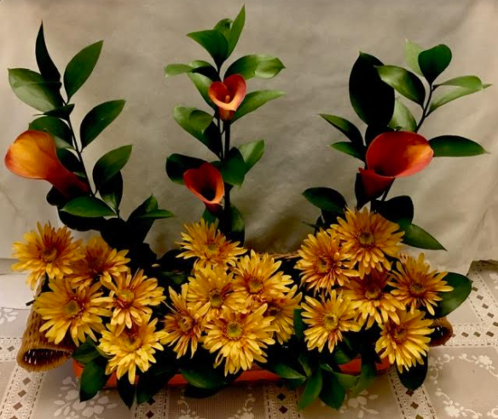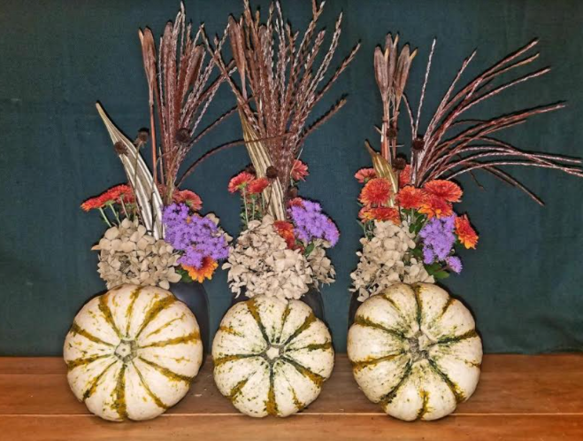
Fran Judd Meg Winn

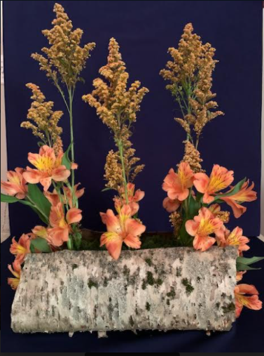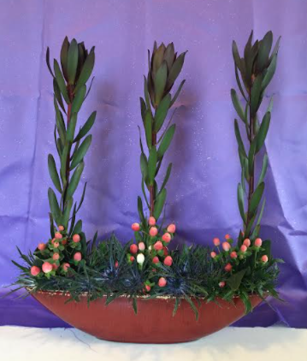

Camille Archie Laurie Kalata

2. Indian Summer - All Dried

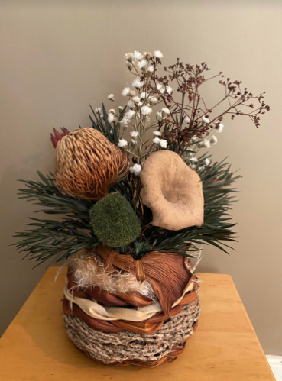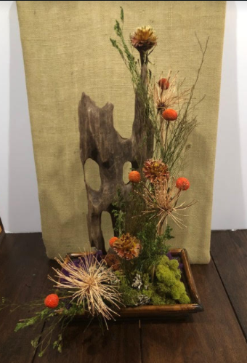

Sandy Fry Lynn Neviaser

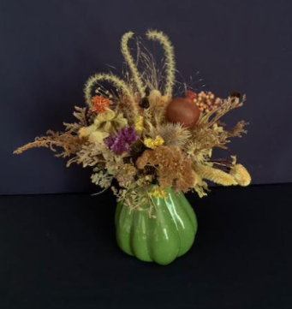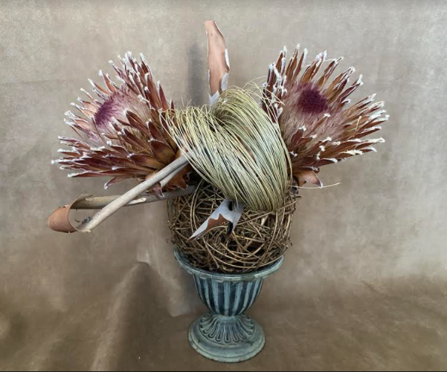

Camille Archie Delora Stites

3. Every “Witch” Way - Designer’s Choice
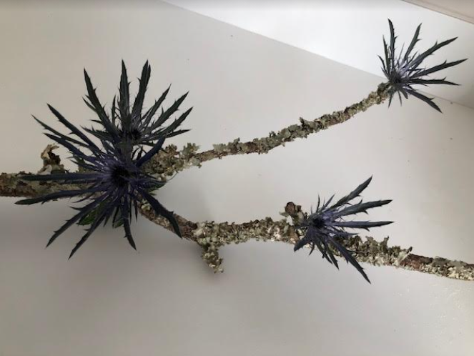\

Gail Tatem Helen Davison

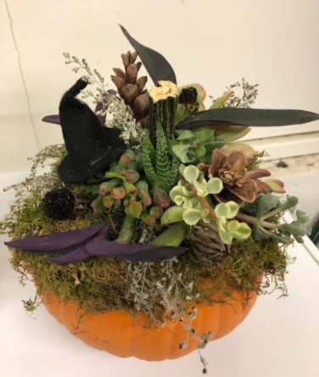

Martie Parch Connie Sorrell

3. Every “Witch” Way - Designer’s Choice (Continued)

Janice Beatty

Botanical Arts - Design
1. Pretty as a Picture - Plaque

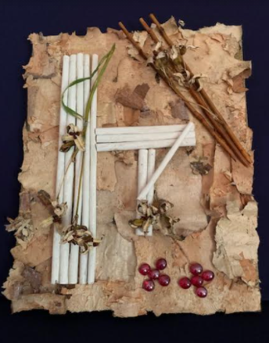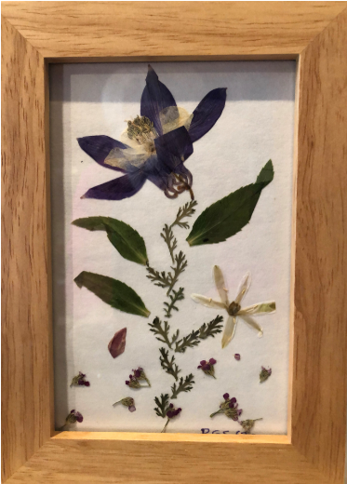
Camille Archie Becky Sido

